
September 2003

COSYSMO DELPHI Round 2

Participant Information:

Name _ ___

Corporation _ ___ Division _ ___

Years of experience in System Engineering and/or Software Engineering _ ____

Years of experience in cost modeling _ ____

Email address _ ______ Phone _ ______

What category would best describe your application domain? (Check all that apply)
Agriculture | Aircraft/Avionics (Commercial jets, helicopters, avionics devices) | Automotive / Motor Vehicles (cars, trucks, buses, etc.)
Data Systems/Information Technology (health care, legal, business records and databases, etc.) | Energy (coal, gas, oil, electric production and distribution, etc.) | Environmental/Waste Mgt (restoration, preservation, conservation, waste mgt, etc.)
Financial | Geographic Information | Infrastructure (Facilities, urban planning, asset mgt, etc.)
Manufacturing | Marine (Boats, ships, etc) | Medical Technology (Medical systems, devices, treatments)
Military/Defense (Tanks, Missiles, etc.) | Natural Resource Management (Water, etc.) | Pharmaceutical/Chemical
Scientific/Research | Space Systems | Telecommunications
Transportation Systems (Railway, Air traffic, Highway, Waterway, etc.) | Other

Point of Contact:
Ricardo Valerdi
University of Southern California
Center for Software Engineering
Email: rvalerdi@usc.edu
Phone: (213) 440-4378
Fax: (213) 740-4927

Introduction
COSYSMO is an acronym for the Constructive System Engineering Cost Model. This member of the USC COCOMO II family of cost estimation models is being developed to accurately estimate the system engineering effort for hardware and software systems.

The COSYSMO model addresses those System Engineering tasks called out by the EIA/ANSI 632 and ISO/IEC 15288 System Engineering standards.

The four factors that we currently believe are sensitive to the size of the effort are called size drivers and the fourteen factors that we believe influence the system engineering effort are called cost drivers.

Our goal with this survey instrument is to poll the system engineering, software engineering, and cost estimation communities to determine the relative significance of these eighteen drivers based on expert opinion. The model will then be tested with historical project data from completed systems to determine its statistical accuracy. Finally, we will fine-tune the model using the data we collect from future surveys to improve its performance and accuracy.

Instructions
This questionnaire is divided into two sections: size and cost. Each section is designed to calibrate specific parameters that we believe impact the estimation of effort during the system engineering life cycle.

Size drivers are characterized via aspects. We are interested in determining a range for the size of each driver and a relative effort rating for each difficulty classification (easy, Nominal, and Difficult).

Cost drivers are characterized using descriptions. Each effort multiplier is assigned a range from its lowest to highest value (Very Low to Very High). The ratio of these values is defined as the Effort Multiplier Ratio (EMR). We need your help in determining the range of these values and the EMR for each driver. An EMR of 1 means that you believe that the driver results in neither a savings nor an increase in effort.

Please indicate the range for each driver based upon your best engineering judgment and experience. Examples are included at the beginning of the Size and Cost sections.

For any clarifications please contact Ricardo Valerdi at rvalerdi@usc.edu or by calling (213) 440-4378.

Part I: Size Drivers
The four size drivers identified are described in the following paragraphs. These drivers are helpful in determining how “big” the system, and in turn the system engineering effort, will be.
Each driver has multiple rows that provide descriptions of the Easy, Nominal, and Difficult values. These rows serve as guides to help you distinguish the difference between and Easy Interface and a Nominal Interface.

We need your help in identifying the typical range and effort associated with each of these parameters. We will use the effort parameter for “Nominal” effort for the Number of System Requirements driver as a basis for comparison to the rest of the size drivers. For each driver, we have provided the results of our initial poll of experts. Use it as a reference. However, disagree with it if you think it is wrong. When you put your numbers down, please provide some rationale in the notes section.
Example:
Number of Major Interfaces
This driver represents the number of shared major physical and logical boundaries between system components or functions (internal interfaces) and those external to the system (external interfaces). These interfaces typically can be quantified by counting the number of external system interfaces and internal interfaces among ISO/IEC 15288-defined system elements.

Easy | Nominal | Difficult
- Well defined | - Loosely defined | - Ill defined
- Uncoupled | - Loosely coupled | - Highly coupled

Previous weights:
Easy: __1.0__ Nominal: __3.0___ Difficult:__7.0___

Your weights:
Easy: __2.0__ Nominal: __5.0___ Difficult:__10.0___

Rationale:
Based upon our experience, even our “Easy” interfaces have two sides and require twice the baseline effort of a “Nominal” system requirement. Our “Difficult” interfaces tend to be negotiated external interfaces requiring more like 10 times the baseline effort.

Enter your responses here

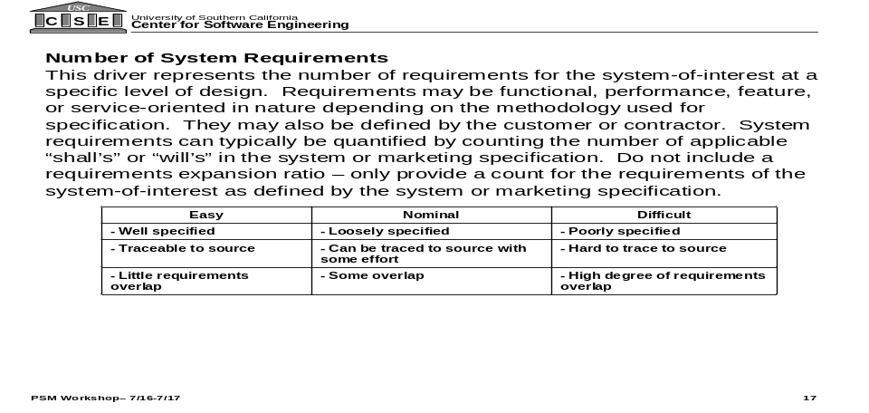Previous weights:
Easy: __0.5___ Nominal: __1.0*__ Difficult: __3.0__

Your weights:
Easy: _ _ Nominal: _ _ Difficult: _ _

*Nominal effort for Number of System Requirements is used as the baseline for comparison to the other size drivers.

Rationale:
__ ___
__ ___
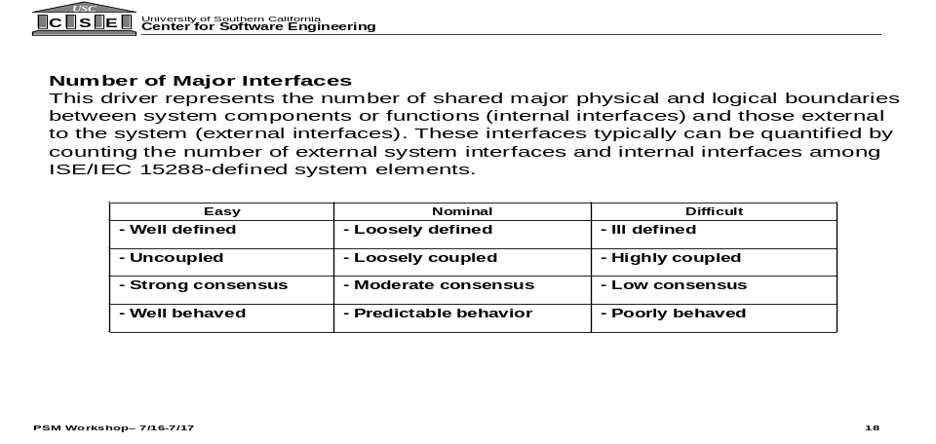
Previous weights:
Easy: __1.0___ Nominal: __3.0__ Difficult: __7.0__

Your weights:
Easy: _ _ Nominal: _ _ Difficult: _ _

Rationale:
__ ___
__ ___

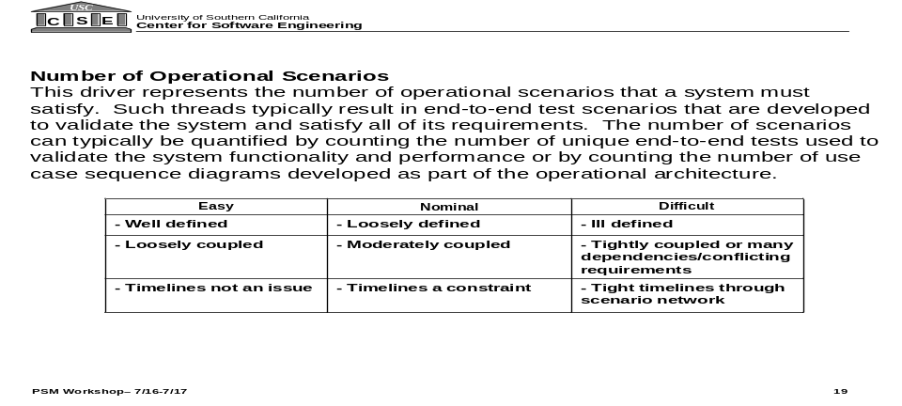
Previous weights:
Easy: __14.0___ Nominal: __29.0__ Difficult: __58.0__

Your weights:
Easy: _ _ Nominal: _ _ Difficult: _ _

Rationale:
__ ___
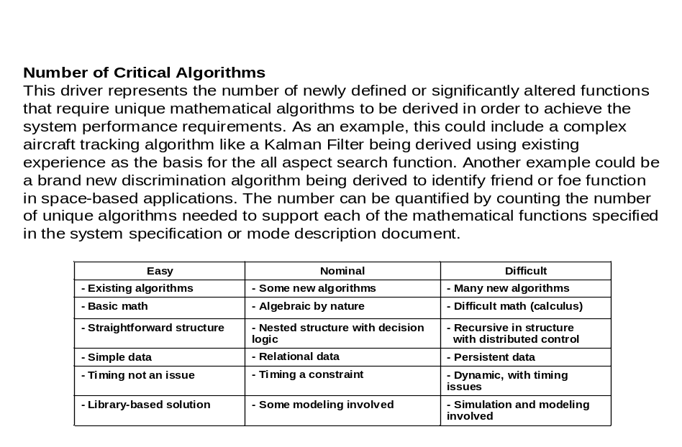
Previous weights:
Easy: __3.0___ Nominal: __6.0__ Difficult: __15.0__

Your weights:
Easy: _ _ Nominal: _ _ Difficult: _ _

Rationale:
__ ___

Part II: Cost Drivers
The fourteen cost drivers and their respective effort multipliers identified are described in the following paragraphs. We need your help in identifying the Effort Multiplier Ratio (EMR) associated with each of these parameters. For example, based upon our experience, we believe that the Requirements Understanding driver extends from a Very Low value of 1.40 to a Very High value of 0.81. The Very Low value means that there is a 40% penalty in effort for poor requirements understanding relative to the norm, or nominal rating. The Very High value says that there is a 19% effort benefit in fully understanding the requirements. Using these values, we would compute the EMR by dividing the very high by the very low value as follows: 1.4/0.81 = 1.73.

For each of the cost drivers, we have put the EMR results assembled by an initial poll of experts. Use it as a reference. However, disagree with it if you think it is wrong. When you put your numbers down, please provide some rationale in the notes section. You can provide either (1) a Very Low/Very High pair or (2) an EMR, whichever you are most comfortable with. The initial values provided include both a Very Low/Very High pair and EMR just for completeness.

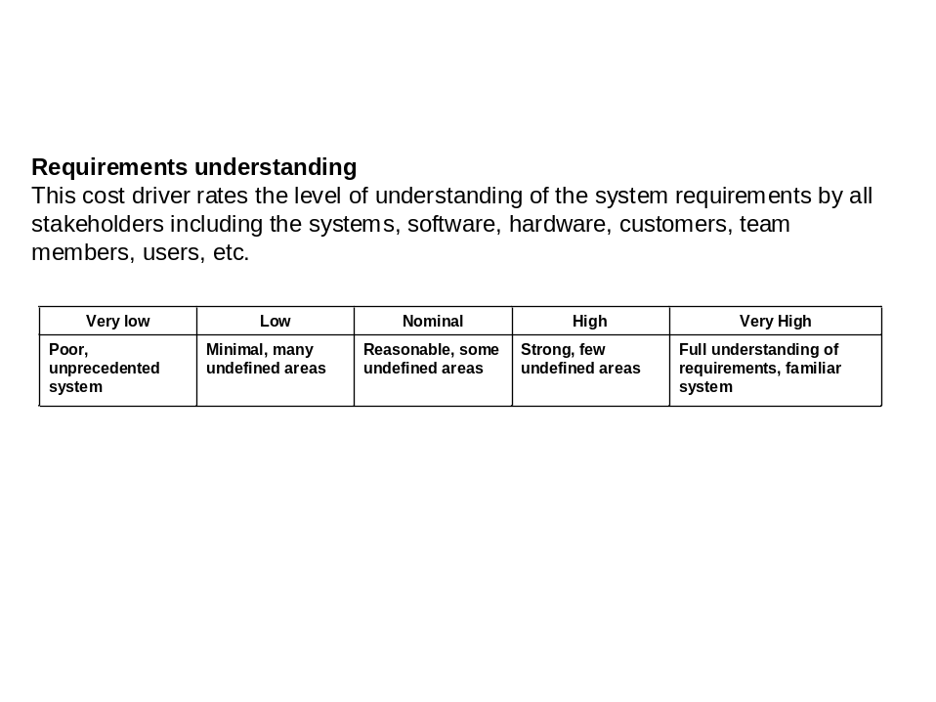
Previous:
Very Low: __1.40__ Very High: __0.81__ EMR: __1.73__

Your:
Very Low: _ _ Very High: _ _ EMR: _ _

Rationale:
__ ___
__ ___
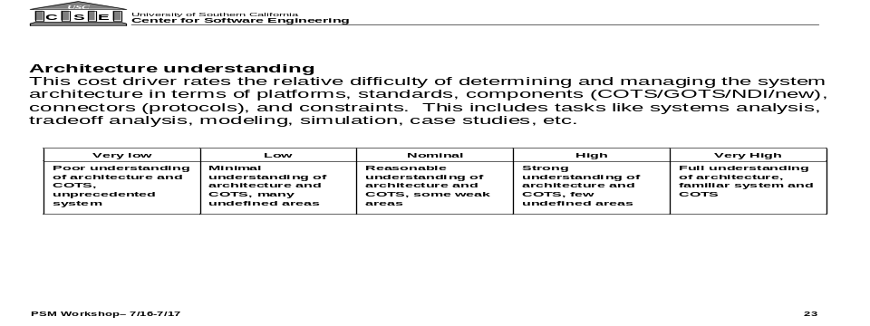
Previous:
Very Low: __1.28__ Very High: __0.77__ EMR: __1.66__

Your:
Very Low: _ _ Very High: _ _ EMR: _ _

Rationale:
__ ___
__ ___

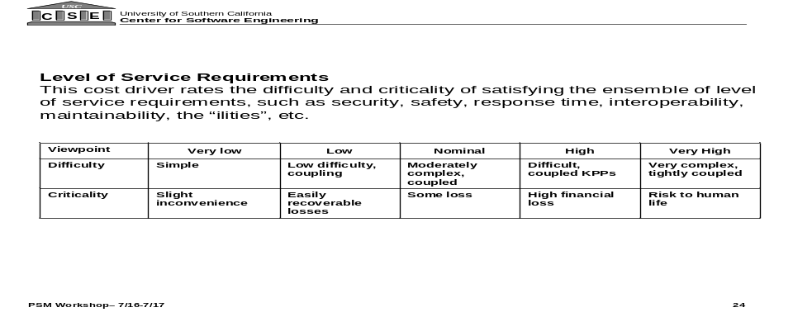Previous:
Very Low: __0.66__ Very High: __1.65__ EMR: __2.50__

Your:
Very Low: _ _ Very High: _ _ EMR: _ _

Rationale:
__ ___
__ ___


Previous:
Nominal: __1.0__ Very High: __1.50__ EMR: __1.50__

Your:
Nominal: _ _ Very High: _ _ EMR: _ _

Rationale:
__ ___
__ ___

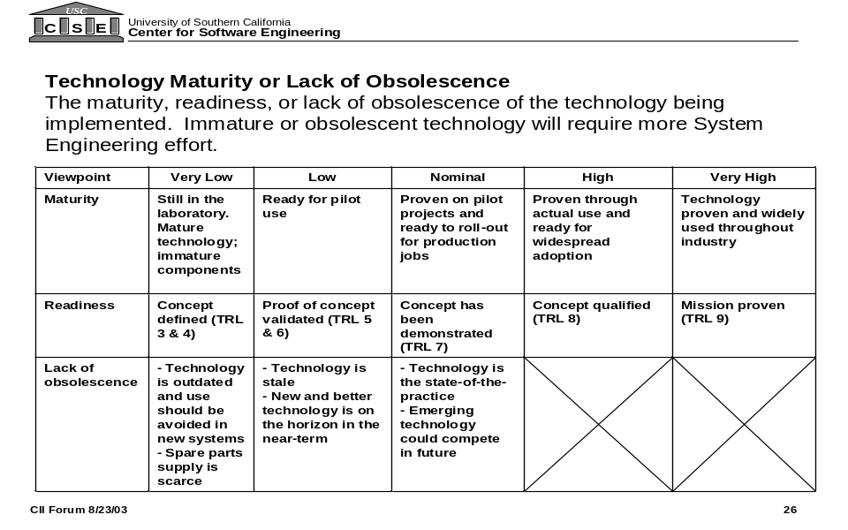
Previous:
Very Low: __1.75__ Very High: __0.70__ EMR: __2.50__

Your:
Very Low: _ _ Very High_ _ EMR _ _

Rationale:
__ ___
__ ___
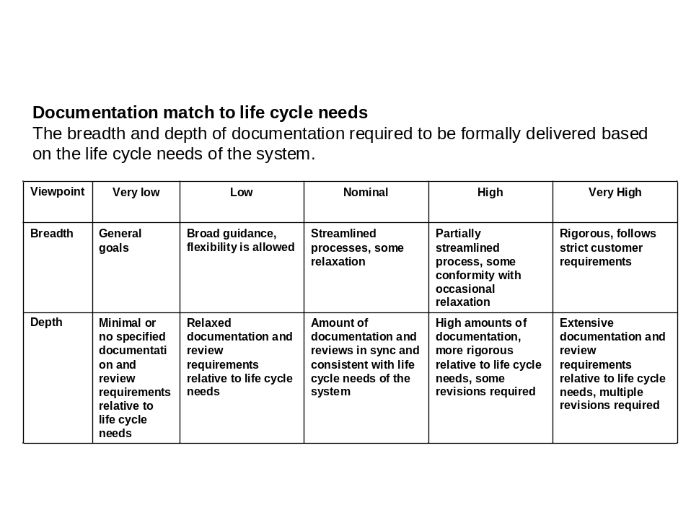
Previous:
Very Low: __0.82__ Very High: __1.23__ EMR: __1.50__

Your:
Very Low: _ _ Very High_ _ EMR _ _

Rationale:
__ ___
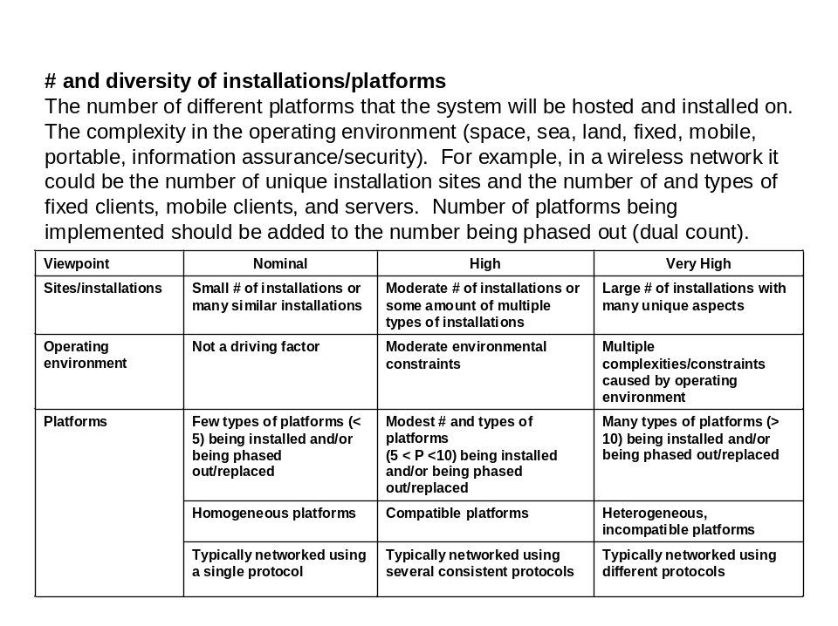
Previous:
Nominal: __1.0__ Very High: __1.50__ EMR: __1.50__

Your:
Nominal: _ _ Very High: _ _ EMR: _ _

Rationale:
__ ___
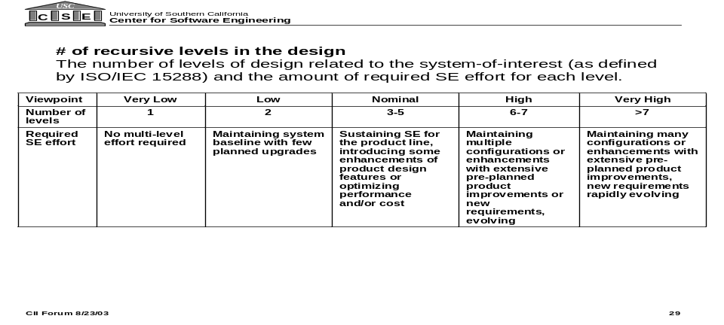Previous:
Very Low: __0.82__ Very High: __1.23__ EMR: __1.50__

Your:
Very Low: _ _ Very High_ _ EMR _ _

Rationale:
__ ___

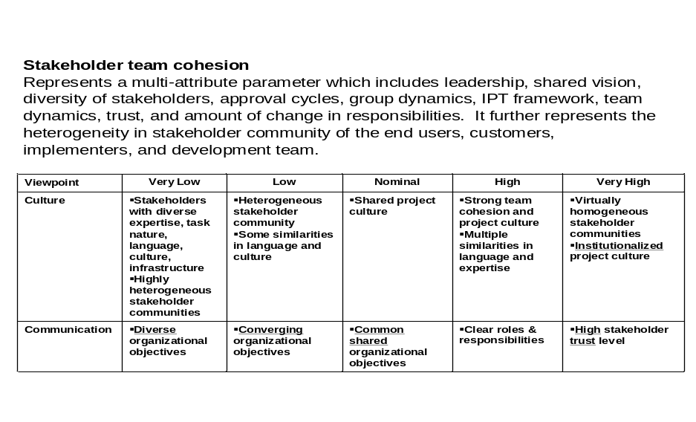
Previous:
Very Low: __1.23__ Very High: __0.82__ EMR: __1.50__

Your:
Very Low: _ _ Very High_ _ EMR _ _

Rationale:
__ ___

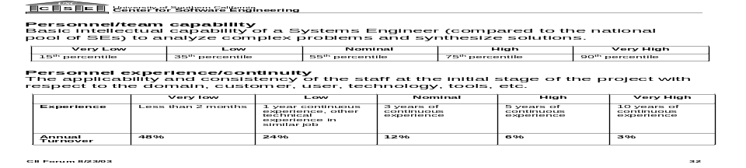Previous:
Very Low: __1.46__ Very High: __0.68__ EMR: __2.15__

Your:
Very Low: _ _ Very High_ _ EMR _ _

Rationale:
__ ___
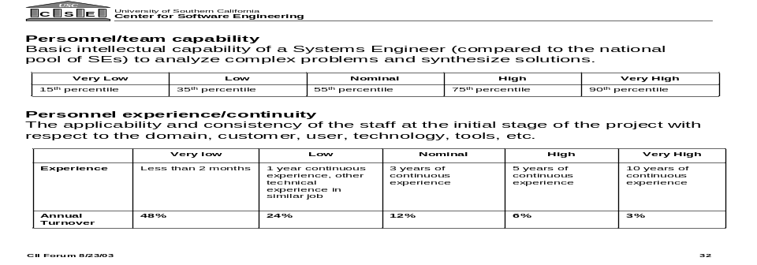

Previous:
Very Low: __1.42__ Very High: __0.71__ EMR: __2.00__

Your:
Very Low: _ _ Very High_ _ EMR _ _

Rationale:
__ ___

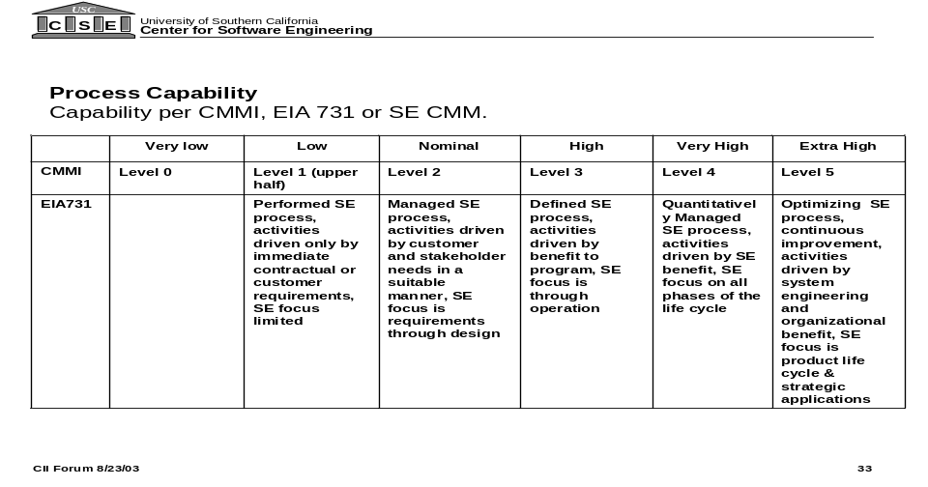Previous:
Very Low: __1.25__ Extra High: __0.85__ EMR: __1.60__

Your:
Very Low: _ _ Extra High_ _ EMR _ _

Rationale:
__ ___
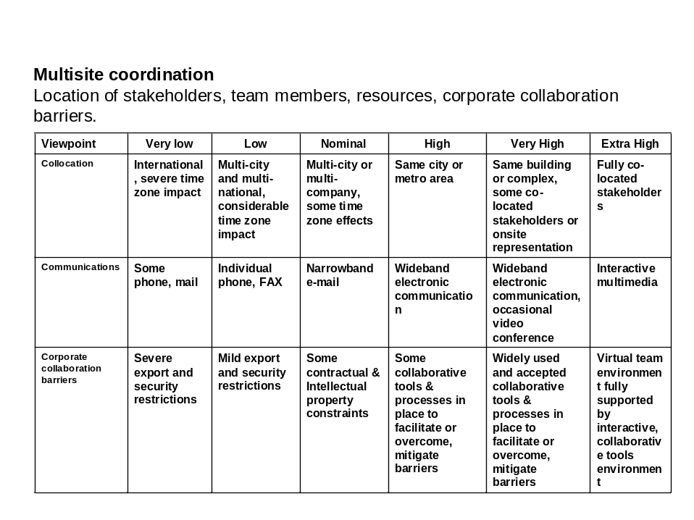
Previous:
Very Low: __1.34__ Extra High: __0.86__ EMR: __1.68__

Your:
Very Low: _ _ Extra High_ _ EMR _ _

Rationale:
__ ___

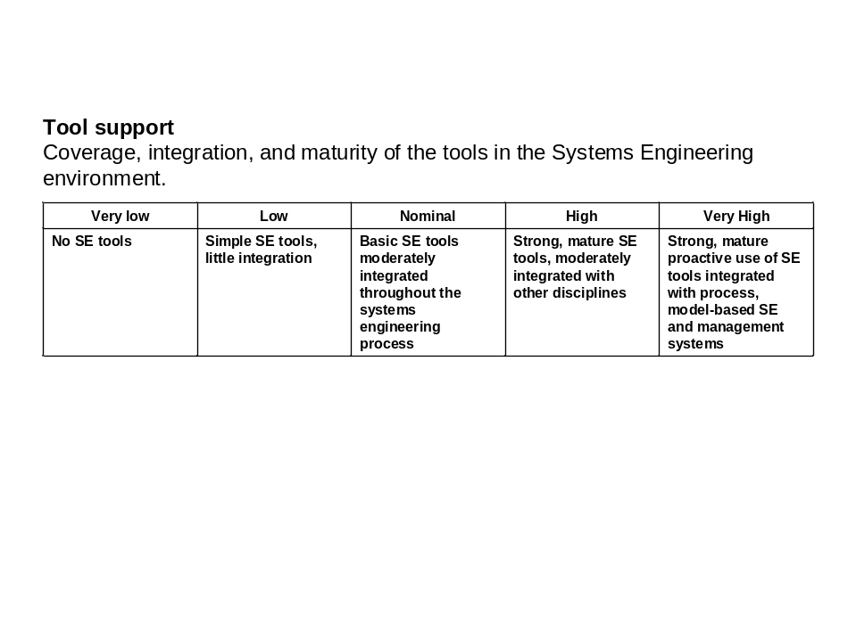

Previous:
Very Low: __1.40__ Very High: __0.75__ EMR: __1.87__

Your:
Very Low: _ _ Very High_ _ EMR _ _

Rationale:
__ ___

